Setwd diye save korle oi folder ei r er shobkichu next theke joma hobe.

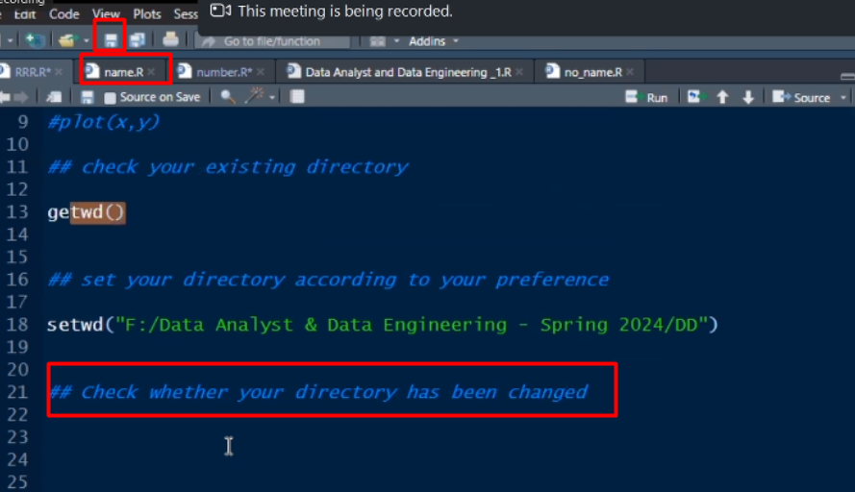

Aivbe check kore dekhbo je amr set kora folder e file save e click korle auto oi folder niye nei naki